Virtual Motorman’s Guide
LT 1959 Tube Stock train V3.0 for MSTS – May 2006.
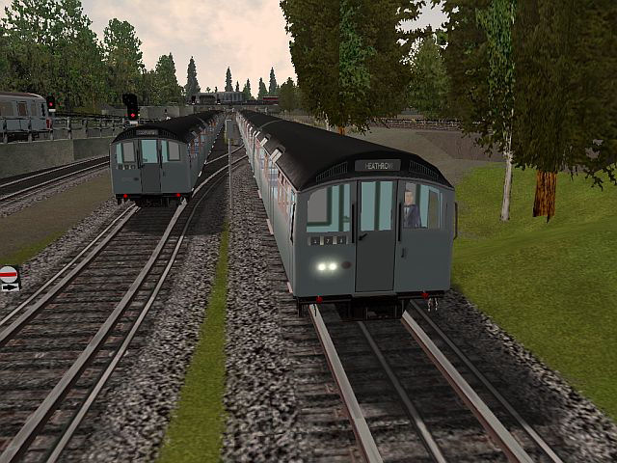
The first 1959 Tube Stock train entered service on the Piccadilly Line on 14th December 1959, and the twentieth train of the delivery began working on the Central Line in July 1960. Afterwards, all the 1959 Tube Stock was transferred to the Piccadilly Line – this being completed by June 1964. They were derived from the 1956 Tube Stock, the first prototype of which entered service in September 1957. Following the introduction of the 73TS on the Piccadilly Line in 1975, the 59TS was transferred to the Northern Line. The stock was finally withdrawn from service in 2000 – this also marking the passing of 2-person (Motorman/Guard) crewing of trains, being superceded by OPO (One Person Operation) stocks.
The picture above shows the 1959 Tube Stock V3 for MSTS, as a Piccadilly service for Heathrow leaves Acton Town on the WB fast road, passing a similar train leaving the West siding.
This V3 train was produced by a team of enthusiasts that included invaluable support from several ex-59TS Motormen. Our goal was to create an updated realistic model of the real 59TS – in appearance, operation and performance. This guide is intended to help you become familiar with the train, its controls and operation; and with practice to become a competent MSTS 59TS Virtual Motorman. Good luck, and enjoy!

Welcome to your train
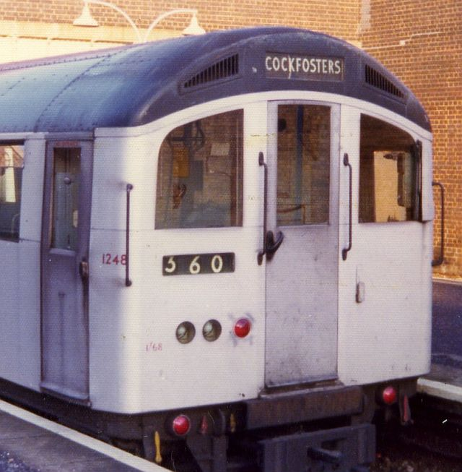
Let’s first examine the 1959 Tube Stock from the outside and understand how a 59TS train set (or consist, in MSTS terms) is made up.
A 59TS train is usually formed of a 4-car unit and a 3-car unit which are coupled to provide a 7-car train. The included consists reflect this arrangement. The Driving Motor units (DMs) have a cab at each end -- these outer cars of each unit being equipped with traction control and motors. The middle cars are un-motored Trailers (T) or Non-Driving Motor (NDM) units (no cabs). The standard 7-car train formation is therefore:
DM-T-NDM-DM + DM-T-DM
The picture shows 1959 Tube Stock DM unit 1248, part of a Piccadilly Line Cockfosters service, set number 360. The front “M” door and cab side doors usually appear darker than the main body as they are formed from cast aluminum, rather than the sheet aluminum of the body. This body construction was lighter than the steel of the earlier tube stocks, such as the 38TS, thus improving performance.
Access to the cab is through one of several doors. Hinged cab side doors provide access from the platform level. The front (or “M” door) allows access in depot areas and may be used for emergency detrainment. A door in the cab rear bulkhead (“J” door) allows access to/from the passenger saloon. The picture above also shows the right (offside) cab door that opens inwards, both of the side doors being hinged on the edge adjacent to the saloon.
The operator’s position is on the left of the cab – usually referred to as the near-side of the cab. There is a fold-away seat for you to use although some motormen with long legs prefer to drive standing, despite some amount of knee space was present unlike the 38TS. In place of a control desk, you will find the operating controls, gauges and two auxiliary control panels. As the following photos will illustrate, this was significantly different to more modern stocks such as the 73TS and D78, but similar to the earlier 38TS.
Before we explore the cab, we’ll take a moment to look more closely at the front of the DM unit and identify a number of important items.
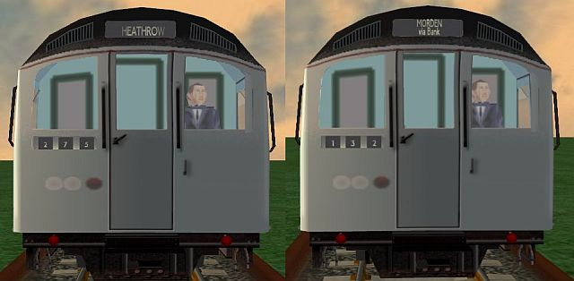

The screenshots above identifies some key components on the DM unit. The whistle is controlled by a button to the left of the window, and is used at specific route locations (marked by Whistle Boards), or to warn Permanent Way crews working on or near the track of the train’s approach. The 59TS whistle and its brass control button are included in the MSTS model (controlled in MSTS by the <spacebar>). The window wiper is hidden behind a screen when not in use. It is animated in the MSTS train and is controlled by the “V” key. The Aux 1 panel wiper control button in the cab also animates.
The destination blind displays the train’s intended final destination. The train set number, identifying the specific train, is located below the offside window. The MSTS 59TS V3 train includes two front texture (ACE) files representing two different train variations. On the left (above) is a Piccadilly Line Heathrow-bound train. On the right is a representation of the last working of the 59TS, on the Northern Line on January 27th 2000, this also being the last Guard-operated train on London Underground. The method to choose either texture set for use in MSTS is described later.
The lights used depend on if the train is in service, and whether the unit is currently a ‘front’ or ‘rear’ unit (white headlights or red taillights and stabling light being illuminated as required). The stabling light lit alone on a rear unit would indicate that the train is currently out of service or ‘stabled’. In the pictures above, the two white lights (under the set number) are the front marker lamps (headlights). The red lamp adjacent to these is the stabling light and will be lit in a rear-end unit when stabled (lights off). The two small red lamps under the body on either side are the red rear taillights, illuminated on the rear unit when in service. The operation of the lighting with the MSTS train is discussed in a later section.
Incidentally, the strange 5-light ‘dice’ type arrangements of the lights used on the 38TS was also used on the 1956 Tube Stock, which was in the majority of aspects the prototype for the 59TS. With the need to show front destination code lights no longer being required, the 59TS instead used the dual white marker lamp arrangement shown above.

An Overview of the Cab
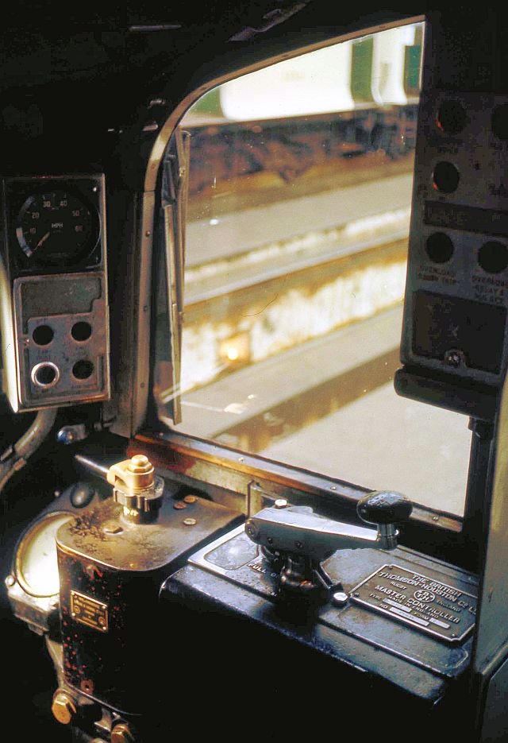
This is where you’ll be spending most of your time – the motorman’s cab – viewed from behind the front “M” door. There are Auxiliary control panels on either side of the motorman’s operating position, various gauges and two sparse control stands. Following sections will illustrate the main cab features. Of particular interest are:
- A panel (Aux 3) to your left, containing a speedometer and various control buttons, with the whistle control button below it, and another panel (Aux 1) seen at the top-right.
- The Drivers Brake Handle (DBH) controlling the EP and Westinghouse brake systems, operated by the motorman’s left hand; and an associated duplex air pressure gauge.
- The selector (obscured), enabling Forward 2, Forward 1, Off and Reverse selections.
- The motoring control (Master Controller) operated by the motorman’s right hand.

CAB CONTROLS OVERVIEW
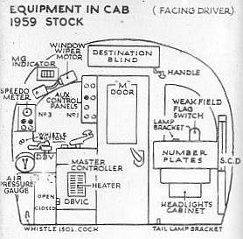
The diagram to the left illustrates the main controls and displays in the 59TS cab, as viewed from inside the cab. To the lower left is the air Duplex gauge, with Auxiliary Panel #3 (Aux 3) above it. This panel houses the speedometer and various control buttons (cab light, etc.). Two control stands house the Driver’s Brake Handle (DBH) to the left, and the Master Controller (MC) to its right. Auxiliary Panel #1 houses more control buttons for the motor-generators, window wiper controls, etc. In the MSTS train, only the wiper ON button on the Aux 1 panel is controllable, as the other electrical functions that these panels operate can not be simulated in MSTS. You should be able to relate the majority of the control items shown in the diagram to those visible in the previous cab photograph.

AUX 3 PANEL / SPEEDOMETER / WHISTLE (LEFT SIDE)
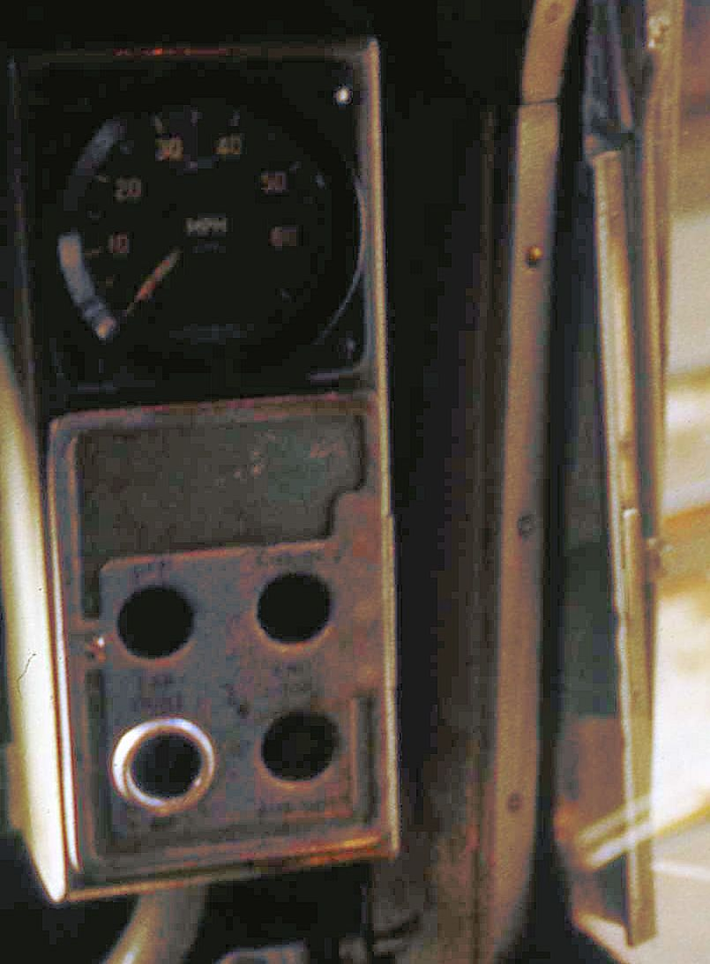
This panel is located to the left of the nearside front window and houses a speedometer, and 4 control buttons. As there is no way to represent or control the button functions in MSTS they are inactive.
The speedometer was in real-life a considerable improvement on that used in the 38TS, being far more accurate and reliable. The MSTS implementation faithfully simulates this. ☺ The speedometer markings are in 10mph intervals, from 0 to 60mph, although the designed speed of the train was about 40-45mph. The author apologizes for the quality of the illustration, it being the best that could be shown given the very few photographs of the 59TS cab that seem to exist.
The train’s whistle control button (valve) can be found just below the Aux 3 panel, and is functional and animated in the MSTS cab model.

DBH AND BRAKE DUPLEX GAUGE (LEFT STAND)
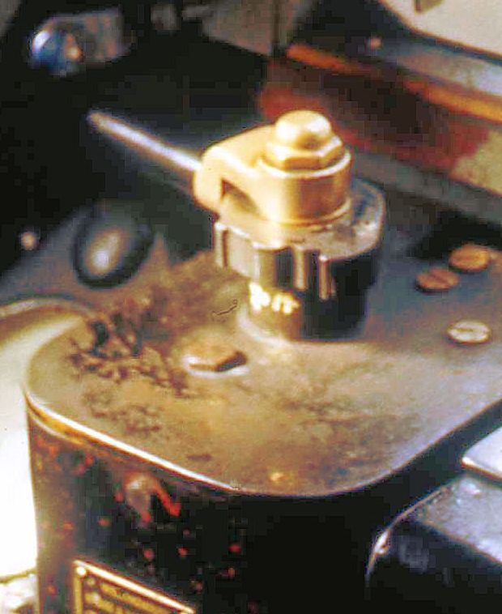
On the left (just visible) is the duplex air pressure gauge, containing two needles. A red needle shows main reservoir pressure, nominally 80-85psi, compressor cut-in at 70-75psi. A black needle shows the train-line air pressure, nominally 65psi. This falls to 52psi at full service braking, or to zero if emergency brake is selected.
The DBH (driver’s brake handle) has several regions of operation, separated by the notches and detents seen on its bezel. Details of brake system operation are described in a later section.
The cab whistle control button can also be seen at the top-left of the photograph.

SELECTOR / MASTER CONTROLLER (RIGHT STAND)
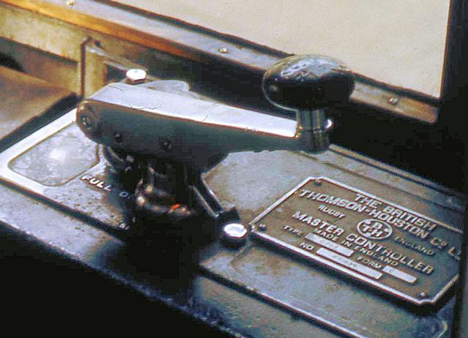
On the right stand are the selector, and master controller. The selector, requiring the motorman’s key to be inserted to operate, allows selection of Off, Forward or Reverse motoring. The Master Controller, incorporating the Deadman’s Handle, selects various levels of motoring, referred to as Off, Shunt, Series and Parallel. These are similar in effect to those positions on more modern stock (e.g. D78), but this control only affects motoring, unlike the CTBC of the D78. Appropriate use of this control is discussed in a later section.

OFFSIDE VIEW OF EQUIPMENT (MSTS screenshot)
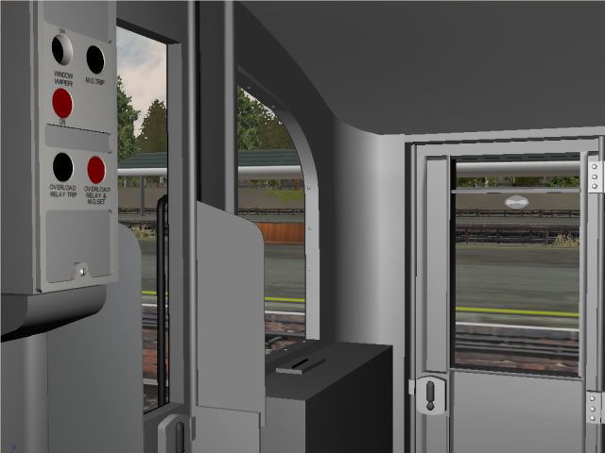
Looking to the right (offside) of the cab from the motorman’s position shows the improved view afforded by the 59TS cab compared to the 38TS. The control box (covered in buttons) nearest to you is the Aux 1 panel noted earlier, and provides control of various train electrical equipment (wipers, motor-generators, etc.).
In the MSTS train, only the wiper ON button (the upper-left red button) is functional and is animated when seen in the front view – as will be shown later.

Train Operation & Controls
Unless you are relieving another train operator and taking over an in-service train, your first job as a 59TS Motorman would be to “open up the train” for service. “Back in the day” you would have been assisted by the train Guard, who had his own set of duties to perform. This process is usually accomplished in the Depot or Stabling Sidings and involves a set of prescribed procedures to make the train ready for passenger service -- these procedures ensuring that all equipment is operational and that the train can be motored. In the MSTS simulation, there are a few operations required before bringing the train into service that are intended to mimic these real-life procedures. As this is a simulation, you may safely assume that the virtual (unseen) Guard will perform his share of the procedures ensuring the train will be ready for service ☺

OPENING UP THE MSTS 59TS FOR SERVICE
When you enter the 59TS train at the start of an MSTS activity or route exploration, the Selector (MSTS Reverser) will be in the OFF (Neutral) notch, the DBH will have a degree of braking applied, the Master Controller will be OFF, and the MSTS train lights switch will be OFF with thus only the rear unit Stabling Light being lit. You will also hear the air compressors bringing up the air pressure to its nominal value and see the duplex air gauge red needle rise to about 85psi. Before being able to motor the train and begin your activity you will need to execute a few simple steps. You may also wish to review your Activity briefing and timetable, if appropriate.

TRAIN LIGHTS
The MSTS 59TS lights are controlled by the “H” and “Shift-H” keys. As all the train lights (except for the rear stabling light) are currently OFF, you will need to press “H” once to turn on appropriate train lighting – i.e. turn on the front unit white lights and the rear unit red lights. The Stabling Light will extinguish. Pressing “H” again will have no further effect. Pressing “Shift-H” will progressively cycle the lighting back to OFF (and re-illuminate the stabling light). The normal procedure, therefore, will be to turn on the correct front/rear train lights by pressing “H” once. You can use the exterior front and rear MSTS views (normally the “2” and “3” views) to confirm that the front and rear unit lights are operating. This simulates the real-life “walk around” the Motorman would perform to verify operation of various items of train equipment.

SELECTOR (MSTS REVERSER)
The real 59TS selector had positions of FOR 2, FOR 1, OFF and REV. In the MSTS 59TS we can simulate the FOR2 (forwards), OFF (neutral) and REV (reverse) positions. Note that in real life, the REV position is very seldom used, and only then during very tightly controlled procedures to facilitate what is essentially a “wrong direction move”! Note also that in the real 59TS, selecting OFF on the selector permitted safely releasing the dead man’s handle on the MC. This detail is not possible to represent graphically in MSTS to a sufficient level of realism, and is thus omitted.
As the Selector is currently in the OFF (neutral) position, you will need to press “W” to select FOR2 (forwards). Pressing “S” moves the selector back to OFF; a further press of “S” would select REV.

FINAL OPENING-UP CHECKS
Confirm that the correct train lights are on, and the saloon doors are closed. Traction current should be available. You can now test that the train will motor by releasing the brakes via the DBH and briefly selecting the SHUNT position on the Master Controller (MC), ensuring train forward movement occurs; and then returning the MC to OFF and re-applying the brakes. The following sections explain the Master Controller (MC) and Driver’s Brake Handle (DBH) operation in detail, including the keys used in MSTS to operate them.

MASTER CONTROLLER (MC)
The MC is a single-handle device (with a safety “dead-man” valve) that controls motoring (unlike the D78 CTBC which also controls braking). In general, you move the MC handle clockwise to increase acceleration and anticlockwise to reduce acceleration or to coast. The MC is a notched controller, having several distinct positions that are used during various driving regimes. Anecdotal examples of the use of these notches are provided in a later section that describes typical driving situations -- and how best to employ the controls to achieve the most realistic behavior of the MSTS 59TS train.
The SHUNT, SERIES and PARALLEL notches are used for motoring, and respectively provide increasing acceleration rates.
The OFF notch is used to coast, having reached a desired speed. The MSTS train has good momentum and will coast realistically.
Control of the MC in the MSTS 59TS is by using the “D” and ”A” keys, which move the MC clockwise and anticlockwise respectively. To perform the MSTS motoring check noted above, you would therefore release the brakes (see DBH section, below) and move the MC from OFF to SHUNT by pressing “D” once. Once movement is confirmed, return to the OFF notch by pressing “A” once, and re-apply the brakes to stop the train.

DRIVER’S BRAKE HANDLE (DBH)
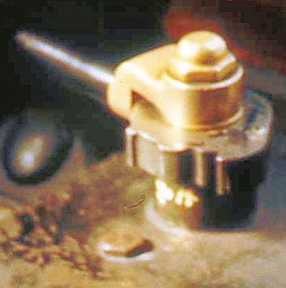
There are several distinct detents on the DBH bezel. These separate the different braking ‘modes’ (EP, Westinghouse, Emergency). The full list of positions is Off (release, running and charging), Hold, EP apply (graduated range), <detent>, Lap, Westinghouse service apply, <big detent>, Emergency. The DBH animations are accurately simulated in the MSTS 59TS cab. As MSTS can not model both EP and Westingouse at the same time, separate train consists have been provided that model each system separately. Selection of these is explained in detail later. The operation and MSTS control keys are described in the following section (titled Brake Systems).
The DBH is shown above in the Off position – the brakes are off and the trainline can re-charge if required after a brake application. Moving the DBH towards yourself would pass through Hold to the EP apply graduated range. Moving it away would result in graduated release of the EP brake in the real train. A Kuju bug in the brake implementation sadly prevents this, but a workaround has been provided (see Brake Systems section). Continuing to move the DBH past the first detent would be the Westinghouse Lap position. Beyond that is the Westinghouse apply range. Moving further (beyond the large detent) selects Emergency braking. We will now discuss how the various braking systems have been modeled and how to use them in the MSTS 59TS.

BRAKE SYSTEMS
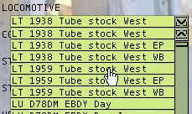
As noted above, the EP and Westinghouse brake system variants have been modeled in different DM “eng” files, and these are used in 3 different LT1959TS consists supplied in the train kit. The variation you wish to use can be easily selected before starting a route exploration by choosing the appropriate consist via the Locomotive pull-down list, as seen in the screenshot to the left. These 3 variations represent respectively:
- EP braking 1 -- no graduated release, train brakes, duplex gauge operable.
- EP Braking 2 -- graduated release kludged to work via engine brakes, air gauge non-operable (EP sufix)
- Westinghouse Brake – realistic operation (WP suffix)
Each variation operates differently, explained in detail in the following sections.

EP Braking 1 (LT 1959 Tube Stock West)
This variation is realistic; except that the real-life graduated EP release can not be simulated. To apply the EP brake, use the <quote> key (MSTS train brake increase key) to move the DBH from Off to Hold, and then again to begin to apply EP brake. Further application (key presses) will gradually increase the level of EP braking. The black needle on the duplex gauge will gradually decrease as you add braking until reading 52psi (a 13psi train-line pressure drop, providing full brake application of 52psi at the brake cylinders). One further increase will select Emergency and 55psi at the brake cylinders. To release the EP brake, use <semicolon> (MSTS train brake decrease key) to reduce the EP setting, go to Hold, and then to Off. Note that although graduated release can not be simulated, you can partially reduce the braking by going to Off and then to Hold. This is not realistic, but may help actual use in MSTS. Note also that if Emergency is selected, the train brakes will not release until Off is selected and the train-line pressure has returned to a nominal value.

EP Braking 2 (LT 1959 Tube Stock West EP)
This is a variant on the above, but uses the engine brake (not train brake) with suitable adjustment to braking force (!), but does allow graduated release. The duplex gauge, however, will not indicate correctly. This variant is provided for anyone who simply wishes to drive the train and would appreciate an easy brake system to use. To apply braking, use the ] key (MSTS engine brake increase). Continue to tap (or hold) the ] key to gradually increase braking. Use the [ key (MSTS engine brake decrease) to gradually decrease braking. The brake force will be proportional to the amount of DBH movement (zero to full brakes) and will allow simply applying and adjusting the brake level required. Emergency can also be selected.

Westinghouse Braking (LT 1959 Tube Stock West WB)
The variation for the die-hard motormen. This is realistically modeled using the train brakes. Use the <quote> key to go straight from Off to Lap (easier than real life!), then use the <quote> key again to apply the service brake. Use the <semicolon> key to return to Lap to hold the brakes. You can then either apply further service brake (apply/lap) or go to Off to release the brakes. Emergency can also be selected. The duplex gauge will indicate correctly, and will show train-line re-charge appropriately.

Duplex Air Gauge
A few further words about the Duplex Air Gauge. As noted earlier, it has 2 needles – the red needle showing main reservoir pressure and the black needle showing train-line pressure. As the brake system has been modeled with accurate values, these needles will show correct pressures during various braking operations. The red needle will show a nominal 80-85psi, falling as the main reservoir pressure is used until the compressors cut-in at about 65-70psi. The needle will then show the re-charge back to nominal pressure during compressor operation (which will also be heard). The black needle will show a nominal 65psi, falling as train-line air is used (to 0psi for Emergency), and returning to nominal pressure when Off is selected on the DBH.
As the duplex gauge will be in your peripheral vision in the MSTS cab display, we felt that it should operate correctly. However, an ex-59TS Motorman has noted that when applying the brakes your attention should be out the front window -- and not looking at the duplex gauge ☺ Braking should be done by observation and feel and not reference to a gauge. After all, you don’t observe a car’s brake pedal to see how much brake you have applied. You simply apply and/or release until it “feels right”. You may wish however – as in real life operation – to check the gauge after a Westinghouse application and release, to ensure train-line pressure is returning to nominal.

READY FOR SERVICE
By this point, you should be familiar with the important panels, switches, buttons, lights and movement controls; understand their purpose – and the MSTS keys that operate them.
The next sections present some anecdotal examples of how to drive the train as is done in real life. The MSTS 59TS uses realistic physics and controls, and you should find that the real-life examples presented can be achieved with some practice.

Driving the 1959 Tube Stock train
These sections describe typical situations you will encounter while driving the MSTS 59TS, and present real-life examples of how to operate the train controls to achieve realistic results.

TRAIN PHYSICS
Much time has been spent ensuring that the performance and behavior of the MSTS 59TS closely matches that of the real train. When supplied with realistic data, the MSTS “physics engine” can produce very good results. This meant utilizing real values for such metrics as car weights and sizes, including passenger loading weight, and determining the right aerodynamic drag and rail friction for the various units in the train set (thanks to Joe Realmuto’s FCALC2 program). The engine power, engine force (torque) and braking force were then be adjusted so as to achieve realistic acceleration, speed, and braking. Typical coasting behavior can also be achieved as a result of the train’s weight (momentum) and the drag/friction equations. If you are familiar with the MSTS D78 or 38TS V2 trains, and have read their included Guides, you will find the same examples presented below. You will also find the modeled performance of the 59TS to be slightly more “sluggish” than the D78, and slightly quicker accelerating compared to the 38TS. This is due to differences in train set configuration, motors, construction materials, weight/drag, etc.
Some detailed aspects of the 59TS control systems can not be precisely modeled in MSTS. Similarly the precise behavior of the traction motors when using Series or Parallel motoring can not be exactly replicated. However, the effects of the real-life train systems have been simulated as closely as possible. Any exceptions to this relate to Kuju-imposed limitations in the Braking systems as discussed earlier.

DRIVING FUNDAMENTALS
At this point in real-world 1959 Tube Stock training, you would be accompanied in the cab by a Road Trainer (equivalent to today’s Instructor/Operators). Part of that veteran’s goal would be to pass on their experience in terms of both route knowledge; and in how best to operate the train in specific situations – making best use of the controls to ensure a comfortable ride for passengers. Your primary driving controls will be both the MC and DBH. Using these may at first seem harder than the simpler single-handle CTBC of stocks like the D78. Some coordination of your two “hands” will be required and you may need to “think ahead” a little more.
Note that if you already have familiarity with the MSTS 1938 Tube Stock V2 train, the general operation of the 59TS is very similar, although performance is a little different.

EXAMPLE DRIVING PROCEDURES
The following are some example procedures that describe how to employ the controls to achieve the desired result. Some examples are paraphrased from Stock training material. It is important to note that all speed limits and signals must be observed and obeyed, therefore you should always “look ahead” to anticipate any speed changes (acceleration or braking) that will be required.
You should consider the example procedures below as guidelines. While the “approaching a station” example describes a typical situation, it is clear that each station approach will be somewhat different. The current line speed, gradients, home signaling and platform curvature (among other factors) will affect approach speed, braking points and brake rates to some degree. Using the example procedures shown below, coupled with knowledge of the line, will yield realistic train operation. One key point to remember is not to “drive the cab”. For example, before accelerating after crossing a turnout make sure the whole train is safely over – and not just your cab!
The first three sections discuss the general fundamentals of accelerating, coasting and braking. They are followed by more specific scenarios, and examples of using (and adjusting) the fundamental procedures as may be needed to suit situations.

ACCELERATING IN GENERAL
When accelerating from rest it is most common to use Parallel motoring, so as to get up to line speed quickly. You should therefore, after releasing the brakes, use the “D” key multiple times to move to the Parallel motoring notch. The train will accelerate – a little sluggishly at first as the train’s inertia is overcome, but there will be a noticeable increase in acceleration around 15-20mph. Above 30mph the acceleration will begin to fall-off. If you were to continue to accelerate, line conditions and speed limits permitting, the train would achieve about 45mph on level track., as the train will accelerate to the so-called ‘balance speed’ of the traction motors. This balance speed can be affected by use of the Weak Field flag switch. When weak field is enabled, the maximum speed of the motors will be increased. It is not possible to simulate changing this switch setting in MSTS, so a decision was made to simulate the performance with the Weak Field flag raised (enabled), so as to provide the required (increased) performance on parts of the LUL combine. You will therefore need to manually ‘coast’ the train (move the MC to Off) to meet line conditions and speed limits, or to use reduced speed on sections of the line where Weak Field would not be used. Note that Series motoring is also sometimes used when accelerating from rest. Examples of this are given in the later scenarios.

COASTING IN GENERAL
Coasting is simply placing the MC in the Off notch and allowing the train to coast at the desired speed. Depending upon the gradient the train speed may decrease, increase, or remain about the same. On level track the speed will decay slowly due to aerodynamic drag and wheel friction, which are modeled. However given the train weight (momentum) the speed decay on level track will be quite gentle.

BRAKING IN GENERAL
The operation of the 3 modeled braking systems has already been explained in detail. A modest EP application (or Westinghouse apply/lap) is adequate to hold a train at rest on most gradients. Unlike what may be expected, it is usual to apply the EP brake to the maximum required level of braking initially, and then reduce or even release the brakes as the train approaches a stand allowing a gentle stop. This procedure serves two purposes – it gets the train under control quickly, and it minimizes the ‘jolt’ to the passengers as the train stops. The key is to determine the level of braking required to meet specific conditions. Suggestions are given in the following example scenarios.
You may find, when initially practicing, that you feel the train will not stop in time, despite employing the suggestions given below. The author was frequently surprised at the effectiveness of the brakes during train testing, until practice provided familiarity with the train behavior. And the braking systems on the 59TS may well require more practice than those of the D78 – but will hopefully provide you with fun and enjoyment.
For a Westinghouse brake application, you will start slowly and apply more and more pressure. This is because you cannot reduce the brake in the way that you can with the EP system. To hold the brake pressure, go to Lap. To release the brake go to Off.
To achieve a perfect Westinghouse stop, apply the brake and go to lap (repeat as necessary), release the brake (Off) before you stop and roll to a halt. You should note that the Westinghouse system takes some skill to use and you will require practice to master it -- in this respect it replicates the original. An experienced Westinghouse motorman would return to the Lap position during a brake application, but would NEVER release the brake until he was ready to roll to a halt. Do not expect to reach this level of competence for some considerable time ☺
The following sections present example scenarios where use of acceleration, coasting or braking may be required; and suggests control methods (e.g. brake levels) that should prove effective. In some cases, content from Stock training material is paraphrased to illustrate typical procedures.

DEPARTING A DEPOT OR STABLING ROAD
When exiting a depot or stabling road, you will always be moving slowly – per low speed restrictions in those areas. To accelerate from rest, use the Shunt or Series motoring notch until reaching the posted speed limit; then select Off to coast. Your speed may be as low as 5-10mph on depot roads or 15mph when crossing turnouts (points). Once clear of the shunt neck and on the main line, you can usually employ Parallel motoring to increase to posted line speed. In some cases local practices may dictate using Series motoring (reduced acceleration) until well clear of the depot or stabling area.

DEPARTING A STATION
When departing a station it is typical to use Parallel motoring until reaching posted line speed, although in some areas Series motoring is recommended until clear of the platform. The following two examples paraphrased from Stock Training material illustrate this:
EXAMPLE 1 – TURNHAM GRN WB TO GUNNERSBURY
Depart in Parallel motoring. At signal GB1, select Off to coast (approx 40mph). Etc…
EXAMPLE 2 – GUNNERSBURY WB TO KEW GDNS
Depart platform in Series motoring with the 45mph PSR in view. At the 6-car marker board select Parallel motoring. At signal GB11, select Off to coast (approx 45mph). Etc…

ACCELERATING TO LINE SPEED
Accelerating to posted line speed will usually be done in Parallel motoring, unless conditions suggest that reduced acceleration may be more appropriate. The leaf season, heavy rain or snow conditions can reduce wheel traction to some degree, and you may need to use Series motoring initially until train momentum increases. Note that you may need to accelerate not only from rest, but also after having reduced speed when required. An example may be after negotiating a turnout (points), or after a signal ahead changes aspect from red to green allowing increased speed.

CROSSING TURNOUTS (POINTS)
Crossing pointwork is often performed at reduced speed (normally posted), whether taking either the straight or diverging route. A good example is the points at Hanger Lane Jct. When going WB, the Piccadilly Line trains (and the odd District train taking an unscheduled Sth. Harrow excursion ☺ ) proceed across the points at 25mph. District trains diverging left to Ealing Broadway will cross the points at a posted 20mph. When going EB, the District trains from Ealing Broadway towards Ealing Common will also cross the points at a posted 20mph. In summary, you will need knowledge of the route pointwork and associated speed limits, and will need to anticipate the required reduction in speed and brake accordingly.

APPROACHING / STOPPING AT A THROUGH STATION
The procedure to brake from line speed to successfully stop “at the mark” at a through station is reasonably consistent, but will differ somewhat in terms of the braking level required and the braking point before the station. These are obviously affected by the line speed approaching the station, the gradient, platform length and curvature, state of approach “home” signals, etc.
The most common procedure on the District Line is to approach the station at 30mph and apply braking at the platform end. As the train approaches the desired stop point, you will likely need to reduce braking to for the last 10-20m. This also reduces the stopping ‘jolt’ as discussed earlier. A good example where this is used is approaching Chiswick Park WB.
In contrast, if line speed is higher and/or there is a down gradient, you will need to use more braking and/or apply it earlier. You will still reduce braking as you approach the stop point. For example, approaching Kew Gdns WB (slight down-grade) at about 45mph, you would need to begin braking about 2 train-lengths before the platform. Note that there may also be a low speed restriction approaching a platform, requiring you to brake earlier/harder than normal.

APPROACHING / STOPPING AT A TERMINUS
There are always low speed restrictions when approaching a dead-end terminus (end of line). Usually this will be a 15mph restriction approaching the station, with a 10mph restriction at the platform end. There may also be speed-sensing approach signaling that will only display a clear aspect once train speed has reduced sufficiently (e.g. 20mph) as measured by a speed-sensing region before the signal.

SUMMARY
Operating the 59TS train efficiently will require practicing the above example procedures until you are comfortable with the train’s performance and know what to expect. Knowledge of the line is required so you can anticipate what actions may be required at various locations. Above all, have fun – driving the 59TS can be very rewarding one you have mastered the train and its controls.
Welcome to the cab – we hope you enjoy the experience…
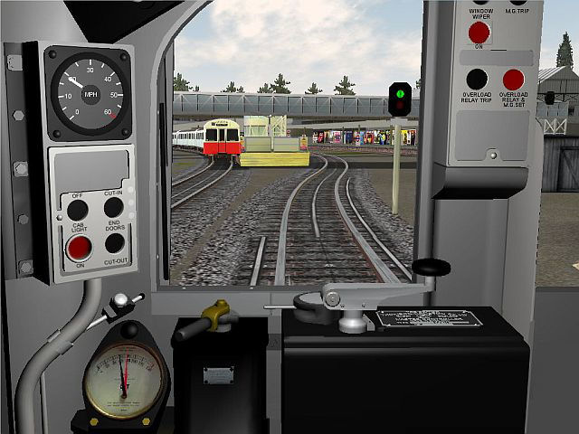

59TS Train variations
The 1959 Tube Stock worked several lines during its time on the LT combine – notably the Piccadilly, Northern and Bakerloo lines. The destination blinds showed the destination and routing. The set numbers were also in a range applicable to the line. The 59TS kit includes graphics depicting both a Piccadilly Line train (Set 275 - Heathrow/Cockfosters), and also depicting the last ever working of the 59TS on the Northern Line (Set 132 - Morden/Edgware) – and are both shown in the above screenshot. Selection of each of these is easily done using either of 2 batch files contained in the 1959 TUBE STOCK folder (MakePic275.bat, or MakeNor132.bat). Executing these will copy appropriate graphic (ACE) files for use. Those with knowledge of editing and creating ACE files can design and add their own new ACE files with destination blinds and set numbers to depict other lines and destinations.

Acknowledgements & Credits
The original 59TS units and the passenger view were created by Richard Scott. Richard’s high-quality freeware models, as well as his commercial work for 3DTS, are well-known to the MSTS community. Richard has kindly agreed to us issuing this complete new V3 version of the train. He is also working on another tube stock that will be of interest to the LUL MSTS fans…stay tuned.
The train’s models, cab and realistic performance could not have been accomplished without the enthusiastic support and contributions of several LT/LUL professionals, some of whom are ex-59TS Motormen. We extend our sincere thanks to them for acting as technical consultants by sharing their knowledge and memories of “back in the day”.
The new 3D cab and animated controls were developed using CAD software by Darren Carter. He has the knack of capturing the atmosphere of the old train stock cabs perfectly, and it was again a pleasure to collaborate with him on a project. Other joint projects are planned ☺ I (Dr Jimi) was responsible for the controls functionality, physics, sounds and lighting for the train.
We all hope you enjoy using this train as much as we enjoyed creating it.
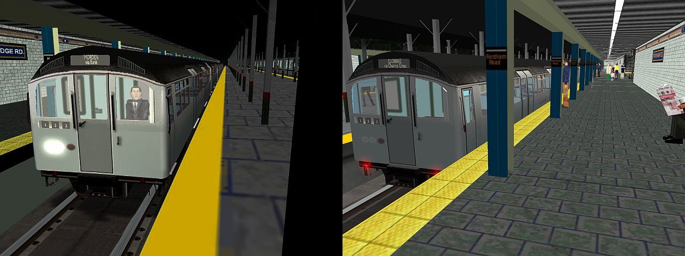

Waiting for the ‘bell’ – Miner Doors! – Gone, but not forgotten…

Set 132 – Morden via Bank / Edgware via Charing X – Jan 27th 2000

Photographs used herein are Copyright © 2006 by District Dave and Piccadilly Pilot, and are used with their kind permission.
The “Equipment in cab – 1959 Stock” diagram was extracted from a leaflet that was originally issued to train crew, published by London Transport (Railways).
LT 1959TS Virtual Motorman’s Guide. Document Copyright © 2006. Virtual District Line Team. All rights reserved.

